AI-Assisted Coding Assignment-9.1

2303A510D1
Batch – 27
Problem 1:
Consider the following Python function: def find_max(numbers): return max(numbers)
Write documentation for the function in all three formats:
1)Docstring
import math

def euclidean_distance(x1, y1, x2, y2):
"""
Calculate the Euclidean distance between two points in 2D space.

Args:
x1 (float): x-coordinate of the first point. y1 (float): y-coordinate of the first point. x2 (float): x-coordinate of the second point. y2 (float): y-coordinate of the second point.

Returns:
float: The Euclidean distance between the two points.
"""
return math.sqrt((x2 - x1)**2 + (y2 - y1)**2)

2)Inline comments
import math

# This function computes the straight-line distance between # two points (x1, y1) and (x2, y2) using the Euclidean formula. def euclidean_distance(x1, y1, x2, y2):

# Compute the difference in x-coordinates dx = x2 - x1

# Compute the difference in y-coordinates dy = y2 - y1

# Apply the square root of the sum of squared differences return math.sqrt(dx**2 + dy**2)

3)Google-style documentation
import math

def euclidean_distance(x1, y1, x2, y2):
"""
Calculates the Euclidean distance between two points in 2D space.

Args:
x1 (float): X-coordinate of the first point. y1 (float): Y-coordinate of the first point. x2 (float): X-coordinate of the second point. y2 (float): Y-coordinate of the second point.

Returns:
float: The Euclidean distance between the two points.

Example:
>>> euclidean_distance(0, 0, 3, 4)
5.0
"""
return math.sqrt((x2 - x1)**2 + (y2 - y1)**2)

Critically compare the three approaches. Discuss the advantages, disadvantages, and suitable use cases of each
style.
1)Docstrings

Advantages
- Always colocated with the function
- Accessible at runtime (help())
- IDE-friendly
- Lightweight but expressive

Disadvantages
- Can become inconsistent without a style guide
- Limited formatting unless combined with conventions (Google, NumPy)

Best use cases
- Small to medium libraries
- Internal tools
- General-purpose Python functions
2) Inline Comments
Advantages
- Explain complex logic line by line
- Helpful for algorithms and non-obvious math
- Great for maintainers reading the implementation
Disadvantages
- Easy to overdo
- Can go stale when code changes
- Do not describe the function’s interface well
Best use cases
- Complex algorithms
- Performance optimizations
- Tricky mathematical derivations
3) Google-Style Documentation

Advantages
- Highly readable and consistent
- Scales well across large codebases
- Excellent for auto-generated documentation
- Examples improve developer experience dramatically

Disadvantages
- More verbose
- Slightly higher upfront effort
- Requires team discipline to maintain consistency

Best use cases
- Public libraries
- Team-based projects
- APIs meant for external users
Problem 2: Consider the following Python function: def login(user, password, credentials): return credentials.get(user) == password
Task:
1. Write documentation in all three formats.
(a) Docstring Documentation def login(user, password, credentials):
"""
Check whether a user's login credentials are valid.

Args: user (str): The username attempting to log in. password (str): The password provided by the user. credentials (dict): A dictionary mapping usernames to passwords.

Returns:
bool: True if the password matches the stored password for the user,
False otherwise.
"""
return credentials.get(user) == password

(b) Inline Comments

def login(user, password, credentials):
# Retrieve the stored password for the given user
stored_password = credentials.get(user)

# Compare the stored password with the provided password

return stored_password == password

c) Google-Style Documentation
def login(user, password, credentials):
"""
Validates a user's login attempt.

Args:
user (str): Username attempting to authenticate. password (str): Password provided for authentication. credentials (dict): Dictionary where keys are usernames and values are their corresponding passwords.

Returns:
bool: True if authentication succeeds, False otherwise.

Example:
>>> creds = {"alice": "1234", "bob": "abcd"}
>>> login("alice", "1234", creds)
True
>>> login("alice", "wrong", creds)
False
"""
return credentials.get(user) == password

2. Critically compare the approaches.
1)Docstrings
Advantages
- Concise and colocated with the function
- Supported by Python tooling and IDEs
- Good balance between detail and brevity
Disadvantages
- Can be vague without a strict format
- Often omit usage examples
Best use
- Small to medium projects
- Internal functions
- Teams with informal documentation needs
2)Inline Comments
Advantages
- Help readers understand how the code works • Useful for explaining non-obvious logic
- Great for beginners reading code line by line
Disadvantages
- Do not describe the function’s interface clearly
- Can clutter simple code
- Easy to become outdated
Best use
- Complex or tricky logic
- Algorithms or edge-case-heavy code
- Supplementing other documentation, not replacing it
3)Google-Style Documentation
Advantages
- Highly readable and consistent
- Clearly defines inputs, outputs, and behavior
- Examples reduce cognitive load for readers
- Scales well across large teams and projects
Disadvantages
- More verbose
- Requires discipline to maintain consistently
- Slightly higher initial writing effort
Best use
- Public APIs
- Large or long-lived projects
- Teams with frequent onboarding
3. Recommend which style would be most helpful for new developers onboarding a project, and justify your choice?

Justification
For new developers, the biggest challenges are:
- Understanding what a function does
- Knowing how to use it correctly
- Avoiding incorrect assumptions
Google-style documentation addresses all three:
- Clear structure reduces confusion
New developers can quickly scan Args, Returns, and Example sections.
- Examples accelerate understanding
Seeing real usage removes ambiguity faster than prose alone.
- Consistency builds confidence
When every function looks the same documentation-wise, onboarding becomes smoother and less error-prone.

Best practice for onboarding
- Use Google-style docstrings for all public-facing functions
- Add inline comments only when logic is not obvious
Problem 3: Calculator (Automatic Documentation Generation) Task: Design a Python module named calculator.py and demonstrate automatic documentation generation.
Instructions:
1) Create a Python module calculator.py that includes thefollowing functions, each written with appropriate docstrings:
add(a, b) – returns the sum of two numbers subtract(a, b) – returns the difference of two numbers multiply(a, b) – returns the product of two numbers divide(a, b) – returns the quotient of two numbers
"""
calculator.py

A simple calculator module that provides basic arithmetic operations. This module demonstrates the use of docstrings for automatic documentation generation using Python's built-in tools.
"""

def add(a, b):
"""
Return the sum of two numbers.

Args:
a (float or int): First number. b (float or int): Second number.

Returns:
float or int: The sum of a and b.
"""
return a + b

def subtract(a, b):
"""
Return the difference of two numbers.

Args:
a (float or int): First number. b (float or int): Second number.

Returns:
float or int: The result of a minus b.
""" return a - b

def multiply(a, b):
"""
Return the product of two numbers.

Args:
a (float or int): First number. b (float or int): Second number.

Returns:
float or int: The product of a and b.
"""
return a * b

def divide(a, b):
"""
Return the quotient of two numbers.

Args:
a (float or int): Numerator. b (float or int): Denominator.

Returns:
float: The result of a divided by b.

Raises:
ZeroDivisionError: If b is zero.
""" if b == 0:
raise ZeroDivisionError("Division by zero is not allowed.") return a / b

- Display the module documentation in the terminal
Using help() inside Python
import calculator
help(calculator)

- Generate and export the module documentation in HTML format using the pydoc utility, and open the generated HTML file in a web browser to verify the output.

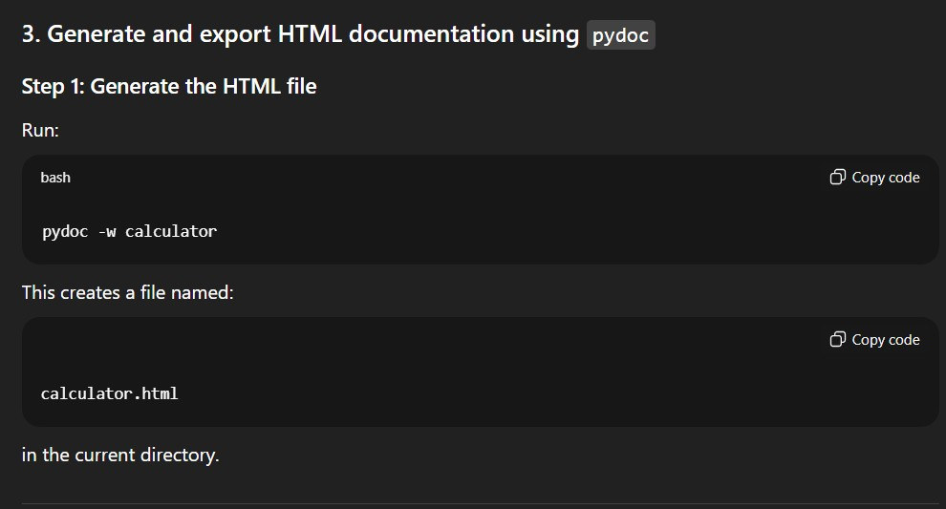
Problem 4: Conversion Utilities Module
1)Write a module named conversion.py with functions:
"""
conversion.py

A utility module that provides functions for converting numbers between different numeral systems such as decimal, binary, and hexadecimal.
"""

def decimal_to_binary(n):
"""
Convert a decimal integer to its binary representation.

Args:
n (int): A non-negative decimal integer.

Returns:
str: Binary representation of the decimal number.
"""
return bin(n)[2:]

def binary_to_decimal(b):
"""
Convert a binary number to its decimal representation.

Args:
b (str): A string representing a binary number.

Returns:
int: Decimal equivalent of the binary number.
"""
return int(b, 2)

def decimal_to_hexadecimal(n):
"""
Convert a decimal integer to its hexadecimal representation.

Args:
n (int): A non-negative decimal integer.

Returns:
str: Hexadecimal representation of the decimal number.
"""
return hex(n)[2:]

- Using Copilot for auto-generating docstrings (Explanation)

When using GitHub Copilot:
  - Write the function definition.
  - Type """ immediately after the function header.
  - Copilot suggests a complete docstring including:
o Description o Arguments o Return values
The docstrings above reflect the typical Copilot-generated style.

- Generate documentation in the terminal
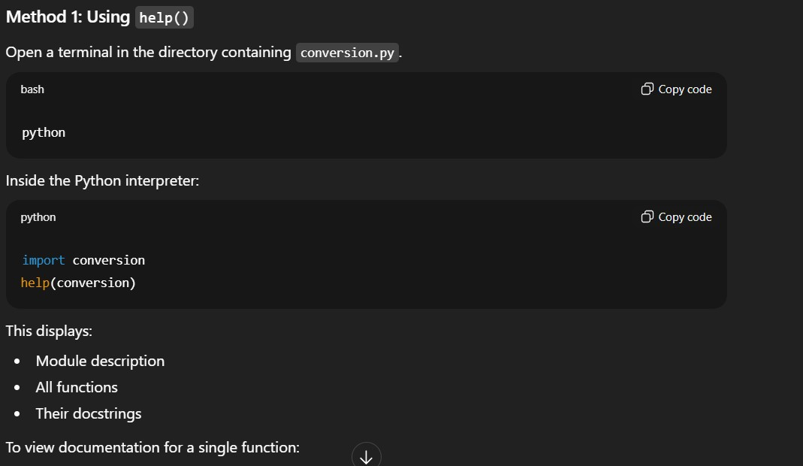
- Export documentation in HTML format and open in a browser
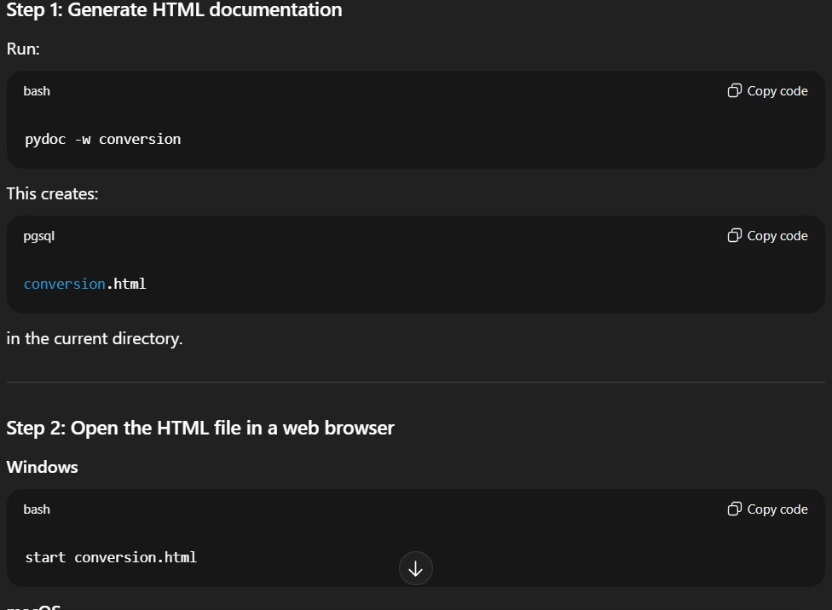

Problem 5 – Course Management Module
1)Create the module course.py
"""
course.py

A simple course management module that allows adding, removing, and retrieving course information.
"""

# Dictionary to store course data courses = {}

def add_course(course_id, name, credits):
"""
Add a new course to the course catalog.

Args:
course_id (str): Unique identifier for the course.
name (str): Name of the course. credits (int): Number of credits for the course.

Returns:
None
"""
courses[course_id] = { "name": name,
"credits": credits
}

def remove_course(course_id):
"""
Remove a course from the course catalog.

Args:
course_id (str): Unique identifier of the course to remove.

Returns:
bool: True if the course was removed, False if not found.
"""
return courses.pop(course_id, None) is not None

def get_course(course_id):
"""
Retrieve details of a course.

Args:
course_id (str): Unique identifier of the course.

Returns:
dict or None: Dictionary containing course details if found, otherwise None.
"""
return courses.get(course_id)
2. Add docstrings with Copilot (Explanation) When using GitHub Copilot in an editor such as VS Code:
- Write the function signature.
- Type """ below the function definition.
- Copilot automatically suggests:
o A short description o Args section o Returns section The docstrings above reflect what Copilot typically generates for CRUDstyle functions.
3.Generate documentation in the terminal
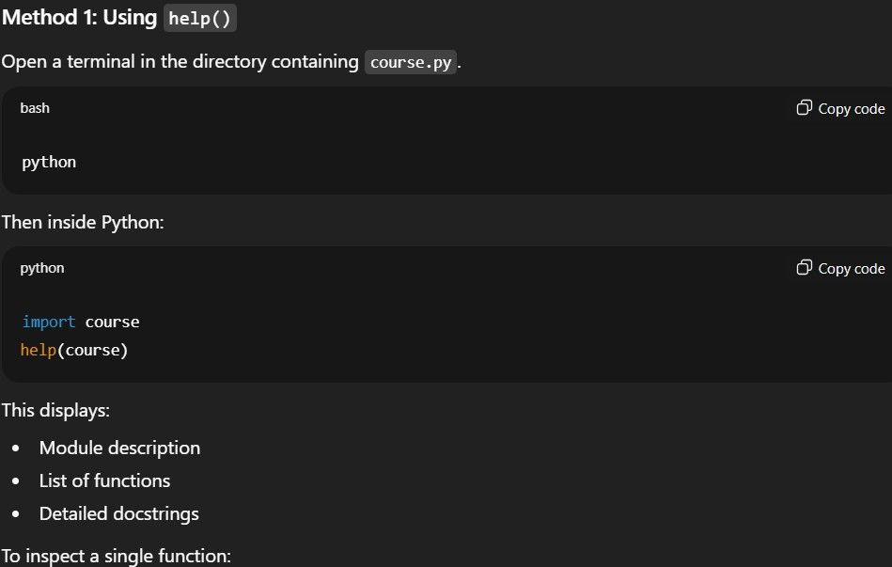

4.Export documentation in HTML format and open it in a browser

